# Hello World RESTful Web Service

HelloController.java -

package com.cognizant.spring_learn.controller;

import org.slf4j.Logger;

import org.slf4j.LoggerFactory;

import org.springframework.web.bind.annotation.GetMapping;

import org.springframework.web.bind.annotation.RestController;

*@RestController*

public class HelloController {

private static final Logger ***LOGGER*** = LoggerFactory.*getLogger*(HelloController.class);

*@GetMapping*("/hello")

public String sayHello() {

***LOGGER***.info("START");

***LOGGER***.info("END");

return "Hello World!!";

}

}

# OUTPUT

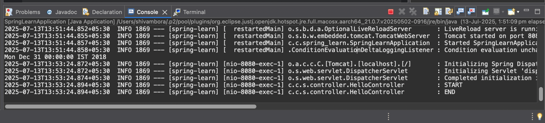

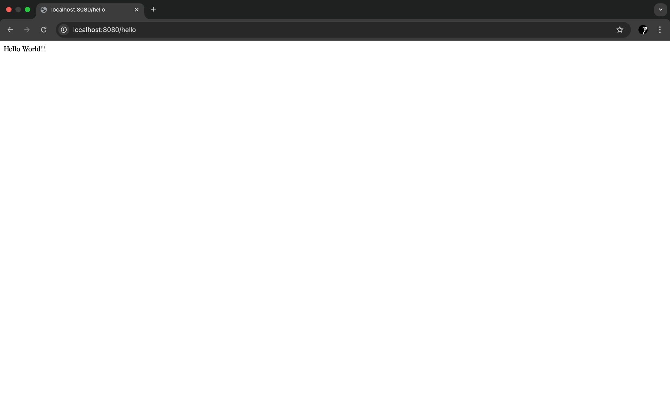

# REST - Country Web Service

## country.xml

<?xml version="1.0" encoding="UTF-8"?>

<beans xmlns="http://www.springframework.org/schema/beans"

xmlns:xsi="http://www.w3.org/2001/XMLSchema-instance"

xsi:schemaLocation="http://www.springframework.org/schema/beans

https://www.springframework.org/schema/beans/spring-beans.xsd">

<bean id="in" class="com.cognizant.spring_learn.model.Country">

<property name="code" value="IN" />

<property name="name" value="India" />

</bean>

</beans>

## 

## CountryController.java

package com.cognizant.spring_learn.controller;

import org.springframework.beans.factory.annotation.Autowired;

import org.springframework.context.ApplicationContext;

import org.springframework.web.bind.annotation.RequestMapping;

import org.springframework.web.bind.annotation.RestController;

import com.cognizant.spring_learn.model.Country;

*@RestController*

public class CountryController {

*@Autowired*

private ApplicationContext context;

*@RequestMapping*("/country")

public Country getCountryIndia() {

Country country = context.getBean("in", Country.class);

return country;

}

}

## 

## Country.java

package com.cognizant.spring_learn.model;

import org.slf4j.Logger;

import org.slf4j.LoggerFactory;

public class Country {

private static final Logger ***LOGGER*** = LoggerFactory.*getLogger*(Country.class);

private String code;

private String name;

public Country() {

***LOGGER***.debug("Inside Country Constructor.");

}

public String getCode() {

return code;

}

public void setCode(String code) {

this.code = code;

}

public String getName() {

return name;

}

public void setName(String name) {

this.name = name;

}

*@Override*

public String toString() {

return "Country [code=" + code + ", name=" + name + "]";

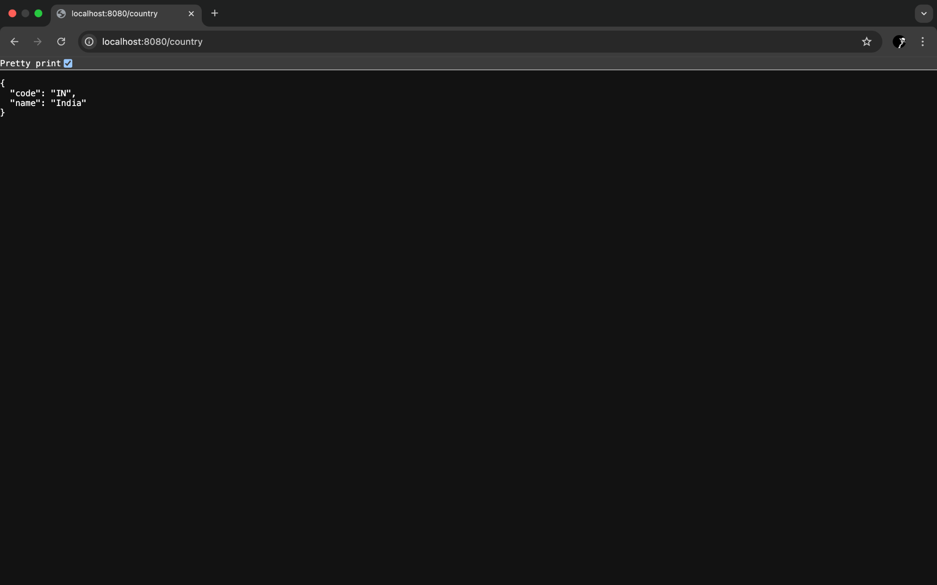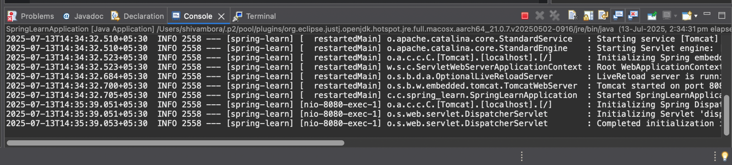

# **3.REST - Get country based on country code**

## CountryService.java

package com.cognizant.spring_learn.service;

import com.cognizant.spring_learn.model.Country;

import org.slf4j.Logger;

import org.slf4j.LoggerFactory;

import org.springframework.beans.factory.annotation.Autowired;

import org.springframework.context.ApplicationContext;

import org.springframework.stereotype.Service;

import java.util.List;

*@Service*

public class CountryService {

private static final Logger ***LOGGER*** = LoggerFactory.*getLogger*(CountryService.class);

*@Autowired*

ApplicationContext context;

public Country getCountry(String code) {

***LOGGER***.info("START");

// 1. Get the country list bean from the context

List<Country> countries = (List<Country>) context.getBean("countryList");

// 2. Use a lambda expression to find the country with a case-insensitive code match

Country foundCountry = countries.stream()

.filter(country -> country.getCode().equalsIgnoreCase(code))

.findFirst()

.orElse(null); // This will return null if no country is found

***LOGGER***.debug("Country: {}", foundCountry);

***LOGGER***.info("END");

return foundCountry;

}

}

## country.xml

<?xml version="1.0" encoding="UTF-8"?>

<beans xmlns="http://www.springframework.org/schema/beans"

xmlns:xsi="http://www.w3.org/2001/XMLSchema-instance"

xsi:schemaLocation="http://www.springframework.org/schema/beans

https://www.springframework.org/schema/beans/spring-beans.xsd">

<bean id="in" class="com.cognizant.spring_learn.model.Country">

<property name="code" value="IN" />

<property name="name" value="India" />

</bean>

<bean id="us" class="com.cognizant.spring_learn.model.Country">

<property name="code" value="US" />

<property name="name" value="United States" />

</bean>

<bean id="de" class="com.cognizant.spring_learn.model.Country">

<property name="code" value="DE" />

<property name="name" value="Germany" />

</bean>

<bean id="jp" class="com.cognizant.spring_learn.model.Country">

<property name="code" value="JP" />

<property name="name" value="Japan" />

</bean>

<bean id="countryList" class="java.util.ArrayList">

<constructor-arg>

<list>

<ref bean="in" />

<ref bean="us" />

<ref bean="de" />

<ref bean="jp" />

</list>

</constructor-arg>

</bean>

</beans>

# OUTPUT

